Product Development laboratory project report on

**Underwater image enhancement**

**Electronics and Communication Engineering**

By

**Deb Mukherjee (121EC0289)**

**Debashis Satpathy (121EC0300)**

**Rishabh Singh (121EC0305)**



**DEPARTMENT OF ELECTRONICS AND COMMUNICATION ENGINEERING**

**National Institute of Technology Rourkela**

April 2024

Table of Contents

**UNDERWATER IMAGE ENHANCEMENT**

CHAPTER-1 3

OBJECTIVE 3

CHAPTER 2 4

Literature Survey 4

CHAPTER 3 5

SOFTWARE DETAILS 5

3.1 ALGORITHM: 5

CHAPTER 4 10

RESULTS AND DISCUSSIONS 10

4.1 RESULTS: 10

4.2 DISCUSSION: 13

CHAPTER 5 15

CONCLUSION: 15

CHAPTER 6 15

References 15

# CHAPTER-1

# OBJECTIVE

Underwater Image Enhancement

With this project we intend to conduct enhancement operations on the underwater images by writing code in python using suitable python libraries.

The resulting/enhanced image would have the right amount of red color intensity and will be of sharp contrast so that features can be extracted properly from the image.

Underwater imagery serves as a valuable resource for studying a myriad of phenomena ranging from marine life to seafloor features such as hydrothermal vents and shipwrecks. However, the inherent challenges posed by the aquatic environment often result in images of subpar quality.

Factors such as limited natural light penetration, coupled with the complex interplay of light refraction, absorption, and scattering, contribute to images characterized by low contrast and color distortion. Notably, the disproportionate scattering of red wavelengths compared to blue and green exacerbates these issues, further compromising the fidelity of underwater visuals.

The techniques that we will be using are adaptive color correction, stationary wavelet transformation, histogram equalization, etc.

Through this initiative, we seek to unlock the full potential of underwater imaging, enabling researchers and practitioners to glean deeper insights into the mysteries of the oceanic realm.

# CHAPTER 2

## Literature Survey

In the domain of image enhancement, specifically underwater image enhancement, the different methods can be broadly divided into two categories. The first category is the use of different conventional/modern image processing algorithms for the enhancement of images, using multiple techniques for different purposes to get a final enhanced image. The second category involves the use of deep learning models for the enhancement of images. These models identify the degradation present in the image and apply the required corrections. Some state-of-the-art methods in the field of underwater image enhancement include conventional methods like underwater dark channel prior(UDCP) [1], generation of dark channel prior(GDCP) [2] , weighted wavelet visual perception fusion(WWPF) [3], minimal color loss and locally adaptive contrast enhancement(MLLE) [4] and deep learning based methods like U-color [5] , U-Shape[6] , TOPAL [7] , Semi-UIR [8].

Underwater images require multiple stages of individual enhancements, like color correction, sharpening, details enhancement, denoising, contrast enhancement, etc. In this field, Zhenbo Wang proposed a method that involves adaptive color correction of each RGB channels, followed by details enhancement through stationary wavelet transform and contrast enhancement [9]. This method includes mostly statistical mathematics and processing based on those formulas. The contrast enhancement method used here includes contrast limited adaptive histogram equalization, explained in the work by Songlin Jin [10].

Other contrast improvement methods include dynamic range separate histogram equalization (DRSHE) [11], in which the histogram of an image is divided into multiple subparts and each subpart is then interpolated based on the ratio of the area of that subpart.[12] Another contrast improvement method is non-linear filtering [13], in which the structure and texture components of the image are separately enhanced and then combined to get the final image.

# CHAPTER 3

# SOFTWARE DETAILS

## 3.1 ALGORITHM:

Input: I

Output: ID

1. Decompose the input image I into R, G, B channels.
2. PRmean ,PGmean ,PBmean ← mean(IR ), mean(IG), mean(IB )
3. PRSSIM, PGSSIM, PBSSIM are calculated by Eqs. (1), (2),(3) given by:

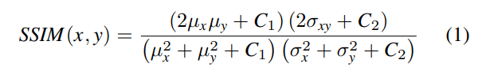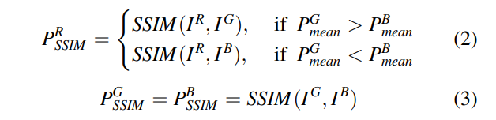

1. if PRSSIM ≤ T then
2. IRN ← compensation of the IR by Eq. (4) and (5):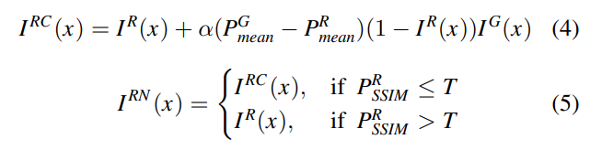
3. else
4. IRN ← IR
5. end if
6. LLc1 , LHc1 , HLc1 , HHc1 are obtained using stationary wavelet transform by Eqs. (9)-(14)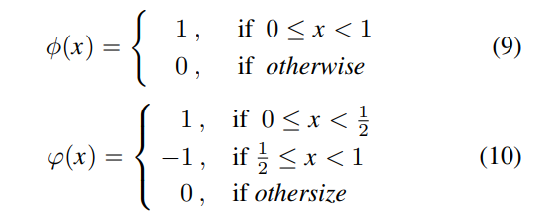

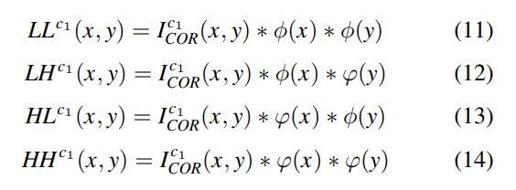

1. Apply Gaussian blur to the LLc1 by Eq. (15):
2. The differential image I c1 F is obtained by Eq. (16):
3. The detail enhanced image Ic1E is obtained by Eq. (17):
4. The enhanced image Ic1D is obtained by performing the inverse wavelet transform.
5. end for
6. Recombine the IRND, IGD, IBD into the composite image ID.
7. ID1 ← GHE(ID), ID2 ← CLAHE(ID), ID3 ← DRSHE(ID)
8. Return ID1 , ID2 , ID3

***DEFINITIONS:***

* SSIM: Structural similarity index measure (Used to calculate channel similarity).
* 𝜇*x* and𝜇*y* : Mean luminance of the channel x and y, respectively.
* 𝜎2x and 𝜎2y: Variance of x and y, respectively.
* 𝜎xy : Covariance of x and y.
* C1 and C2: Stabilization factors.
* PRSSIM: Represents the SSIM value of the red channel with channel with maximum pixel average.
* IR , IG, and IB: Represent the R, G, and B channels of the original underwater image I, respectively.
* PGmean and PBmean: Represent the pixel average of the green channel and the pixel average of the blue channel, respectively.
* PGSSIM and PBSSIM: Represent the SSIM values of the green channel and the blue channel.
* IRC: Represents the compensated red channel.
* IR(x) and IG(x) represent each pixel value of the original red channel and green channel, respectively.
* α: Compensation factor.
* PC1mean and PC2var : The mean and variance of each color channel of the underwater image, respectively.
* PCmax and PCmin : The maximum and minimum values used for normalization.
* λ is a parameter controlling the dynamic range of the image.
* Ic1COR: Represents the color corrected image.
* ϕ(x): Scale function
* φ(x): wavelet function
* LLc1: low-frequency component of each channel after color correction and G1 is the Gaussian filter.
* IC1F: The difference image between LLc1 and the blurred image IC1M by equation (16).
* β: An adjustable parameter that determines the degree of image sharpening.
* IC1D: Represents the channel obtained by inverse wavelet transform.
* ϕ-1(x) and φ-1(x) are the inverse scale function and inverse wavelet function of Haar wavelet, respectively.
* GHE: Global Histogram Equalization
* CLAHE: Contrast Limited Adaptive Histogram Equalization
* DRSHE: Dynamic Range Separate Histogram Equalization

***PARAMETER TABLE***

|  |  |
| --- | --- |
| PARAMETER | VALUE |
| Red Channel Compensation Threshold | 0.7 |
| Red Channel Compensation Factor | 0.5 |
| Gaussian Blur Kernel Size | (5,5) |
| Sharpening Factor | 3 |
| Contrast Threshold(CLAHE) | 0.01 |
| No. Of Segments(CLAHE) | 8 x 8 |
| Dynamic Range Threshold(DRSHE) | 0.002 |
| No. Of Sub-Histograms (DRSHE) | 4 |
| Gamma Correction Constant | 255/log10(256) |
| Gamma | 2 |

FLOWCHART:

**Figure 1**

# CHAPTER 4

# RESULTS AND DISCUSSIONS

## 4.1 RESULTS:

In this section, we first introduce the datasets used throughout the project. Then we compare the results obtained with existing state-of-the-art methods. We also analyzed the contribution of applying SWT in underwater image detail enhancement in this section, as well as the effect of applying CLAHE for luminance equalization in the final stage of the processing flow.

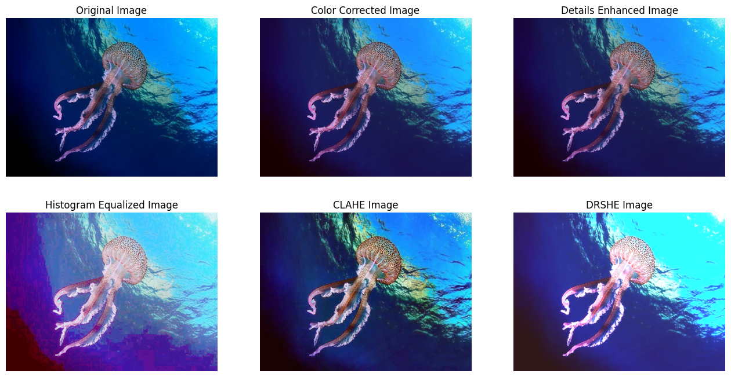

**Figure 2**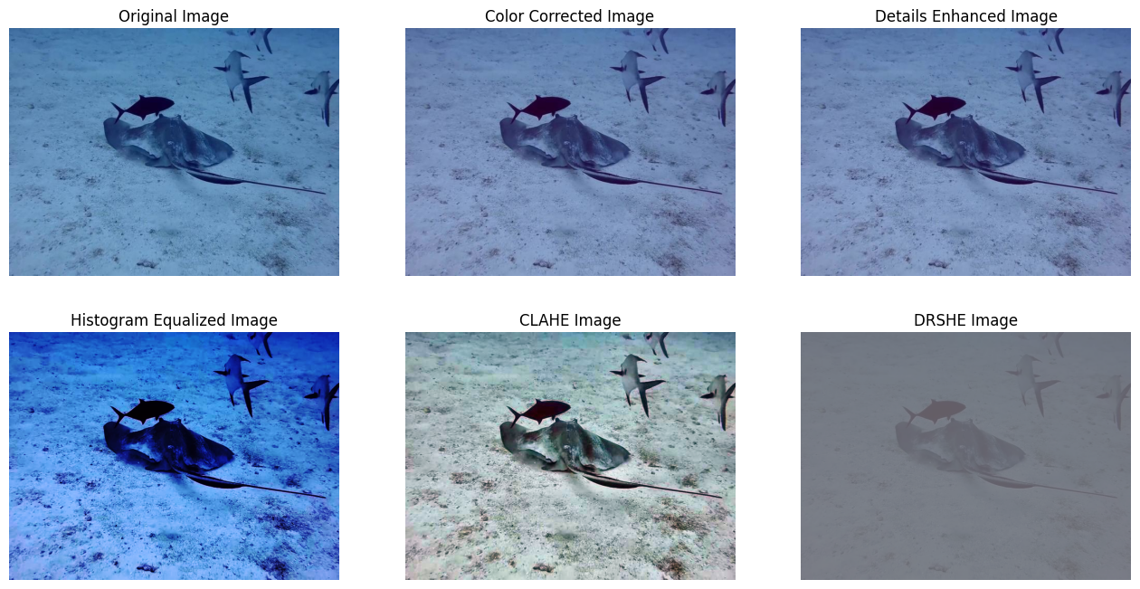

**Figure 3**

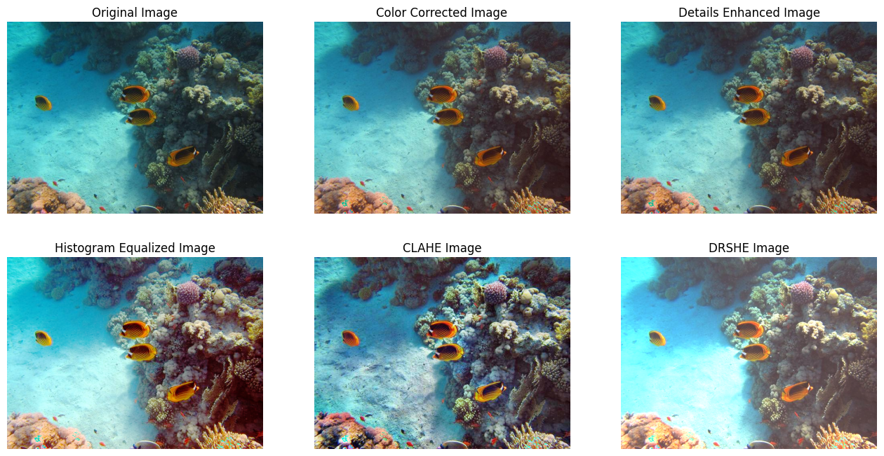

**Figure 4**

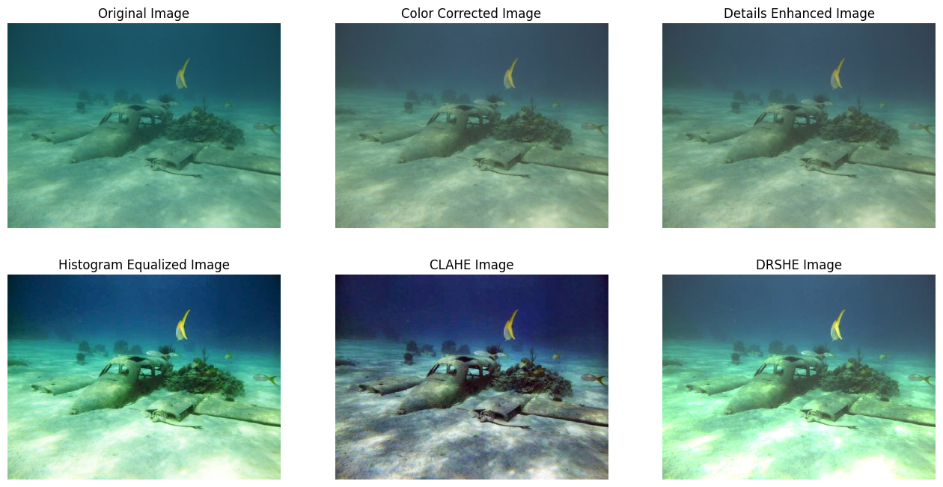

**Figure 5**

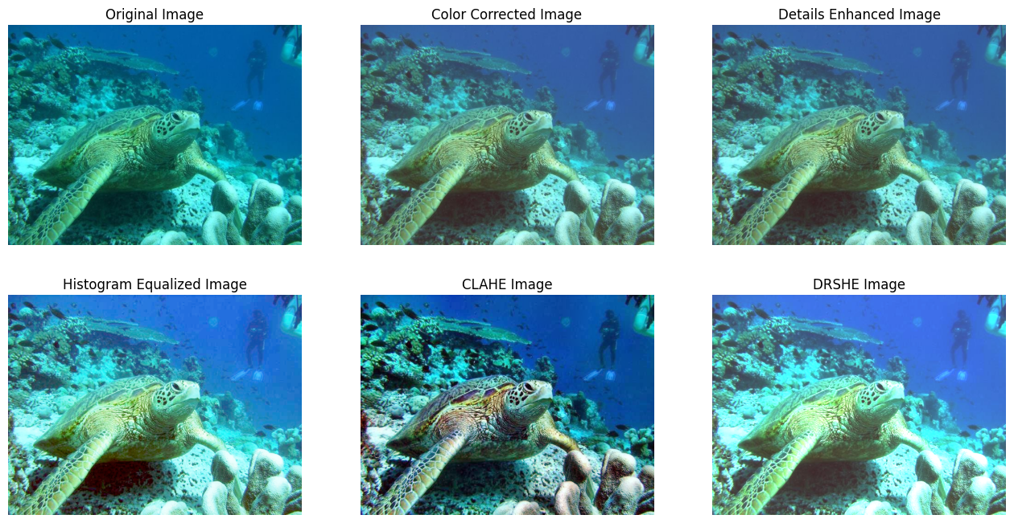

**Figure 6**

## 4.2 DISCUSSION:

**A. Datasets**

In this paper, we conducted experiments based on the SUIM (Semantic Segmentation of Underwater Imagery) dataset, which contains 110 actual underwater images including various underwater scenes such as deep-sea fish, coral reefs, submarine cables, and so on. These datasets provide a challenging and diverse test environment as they cover many distinct types of underwater scenes and visual degradation phenomena. This allows us to conduct more comprehensive comparative experiments to verify the generalization ability of different methods under different underwater conditions and scenarios.

**B. Methods Used**

This section introduces a comparative study aimed at the methods used throughout this paper on the performance of our Underwater Image Enhancement. Firstly, we started with Adaptive Color Correction which solved the issue of larger wavelengths of red channels. Due to this large wavelength, the red channel gives less contribution to the overall image in comparison to green and blue channels which become dominant. After that we performed Stationary Wavelet Transform which focused on detail Enhancement and Sharpening of the image. We used stationary wavelet transform (SWT) rather than discrete wavelet transforms (DWT), because the stationary wavelet has translation invariance and produces a stable response to small translations of the image. We choose the simplest member of Daubechies wavelets, the db1(Haar) wavelet to make the objects and structures in underwater images more clearly recognizable, and further enhance the overall visibility and recognition of the images. Also, we had applied Contrast Enhancement techniques such as normal histogram equalization and CLAHE to provide a specific impact on the performance of underwater images.

**C. State-of-the-art Methods**

To comprehensively evaluate our method , we compared the results obtained by our method with existing state-of-the-art methods in underwater image enhancement domain , which is minimal color loss and locally adaptive contrast enhancement(MLLE) [4] and found that our method gives better results majority of the times.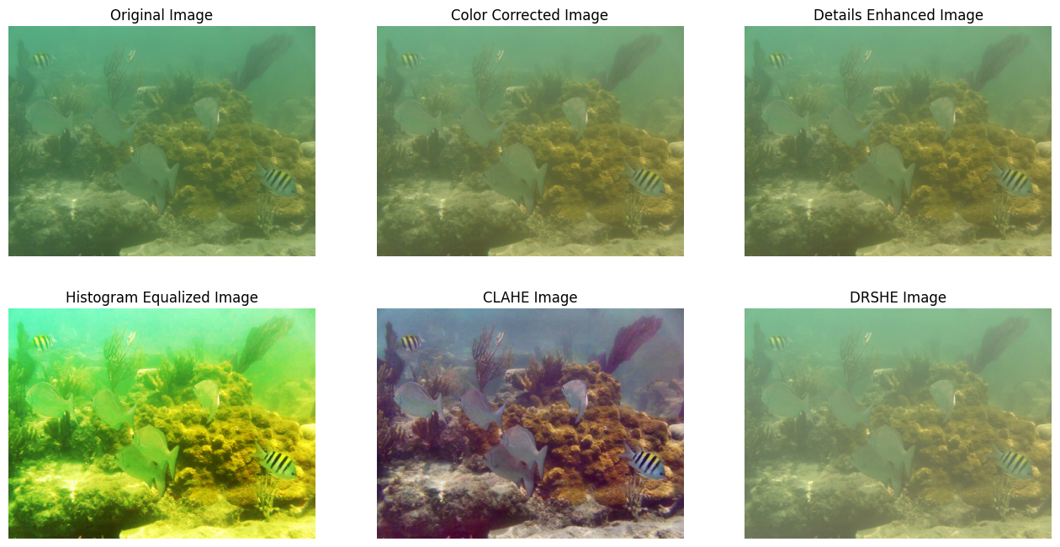

**Figure 7 : Results obtained by us.**

**Figure 8: Results obtained by MLLE.**

# CHAPTER 5

# CONCLUSION:

# We used an underwater image enhancement method, which includes three parts: adaptive color correction, detail sharpening, and contrast enhancement. Our proposed method realizes the color compensation from multi-channel to color correction. It solves the detail blurring and low contrast by the detail sharpening of the stationary wavelet transform and the local contrast enhancement of CLAHE. We also performed other contrast improvement methods like DRSHE and histogram equalization and compared the results obtained by the results of an existing state-of-the-art method MLLE.

# CHAPTER 6

## References

[1] P. Drews Jr, E. do Nascimento, F. Moraes, S. Botelho and M. Campos, "Transmission Estimation in Underwater Single Images," 2013 IEEE International Conference on Computer Vision Workshops, Sydney, NSW, Australia, 2013, pp. 825-830, Doi: 10.1109/ICCVW.2013.113.

[2] Y. -T. Peng, K. Cao, and P. C. Cosman, "Generalization of the Dark Channel Prior for Single Image Restoration," in IEEE Transactions on Image Processing, vol. 27, no. 6, pp. 2856-2868, June 2018, Doi: 10.1109/TIP.2018.2813092.

[3] W. Zhang et al., "Underwater Image Enhancement via Weighted Wavelet Visual Perception Fusion," in IEEE Transactions on Circuits and Systems for Video Technology, vol. 34, no. 4, pp. 2469-2483, April 2024, Doi: 10.1109/TCSVT.2023.3299314.

[4] W. Zhang, P. Zhuang, H. -H. Sun, G. Li, S. Kwong, and C. Li, "Underwater Image Enhancement via Minimal Color Loss and Locally Adaptive Contrast Enhancement," in IEEE Transactions on Image Processing, vol. 31, pp. 3997-4010, 2022, Doi: 10.1109/TIP.2022.3177129.

[5] C. Li, S. Anwar, J. Hou, R. Cong, C. Guo, and W. Ren, "Underwater Image Enhancement via Medium Transmission-Guided Multi-Color Space Embedding," in IEEE Transactions on Image Processing, vol. 30, pp. 4985-5000, 2021, Doi: 10.1109/TIP.2021.3076367.

[6] L. Peng, C. Zhu, and L. Bian, "U-Shape Transformer for Underwater Image Enhancement," in IEEE Transactions on Image Processing, vol. 32, pp. 3066-3079, 2023, Doi: 10.1109/TIP.2023.3276332.

[7] Z. Jiang, Z. Li, S. Yang, X. Fan and R. Liu, "Target Oriented Perceptual Adversarial Fusion Network for Underwater Image Enhancement," in IEEE Transactions on Circuits and Systems for Video Technology, vol. 32, no. 10, pp. 6584-6598, Oct. 2022, Doi: 10.1109/TCSVT.2022.3174817.

[8] S. Huang, K. Wang, H. Liu, J. Chen, and Y. Li, "Contrastive Semi-Supervised Learning for Underwater Image Restoration via Reliable Bank," 2023 IEEE/CVF Conference on Computer Vision and Pattern Recognition (CVPR), Vancouver, BC, Canada, 2023, pp. 18145-18155, Doi: 10.1109/CVPR52729.2023.01740.

[9] Z. Wang, D. Zhou, Z. Li, Z. Yuan, and C. Yang, "Underwater Image Enhancement via Adaptive Color Correction and Stationary Wavelet Detail Enhancement," in IEEE Access, vol. 12, pp. 11066-11082, 2024, Doi: 10.1109/ACCESS.2024.3354169.

[10] S. Jin, P. Qu, Y. Zheng, W. Zhao, and W. Zhang, "Color Correction and Local Contrast Enhancement for Underwater Image Enhancement," in IEEE Access, vol. 10, pp. 119193-119205, 2022, Doi: 10.1109/ACCESS.2022.3221407.

[11] G. -H. Park, H. -H. Cho and M. -R. Choi, "A contrast enhancement method using dynamic range separate histogram equalization," in IEEE Transactions on Consumer Electronics, vol. 54, no. 4, pp. 1981-1987, November 2008, Doi: 10.1109/TCE.2008.4711262.

[12] T. Iwanami, T. Goto, S. Hirano, and M. Sakurai, "An adaptive contrast enhancement using regional dynamic histogram equalization," 2012 IEEE International Conference on Consumer Electronics (ICCE), Las Vegas, NV, USA, 2012, pp. 719-722, Doi: 10.1109/ICCE.2012.6162054.

[13] T. Goto, M. Akiyama, and S. Hirano, "Contrast Enhancement and Detailed Enhancement Method Based on Non-Linear Filtering," 2018 IEEE International Conference on Consumer Electronics-Taiwan (ICCE-TW), Taichung, Taiwan, 2018, pp. 1-5, Doi: 10.1109/ICCE-China.2018.8448626.